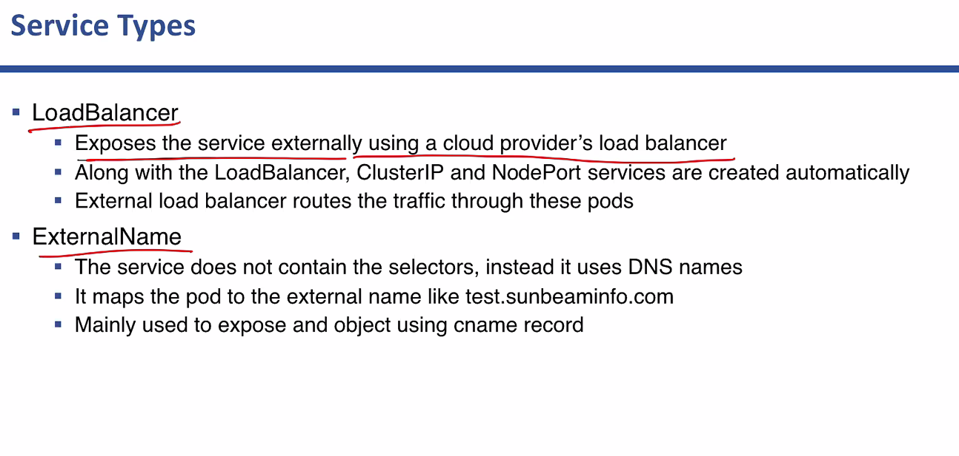

Deployments:

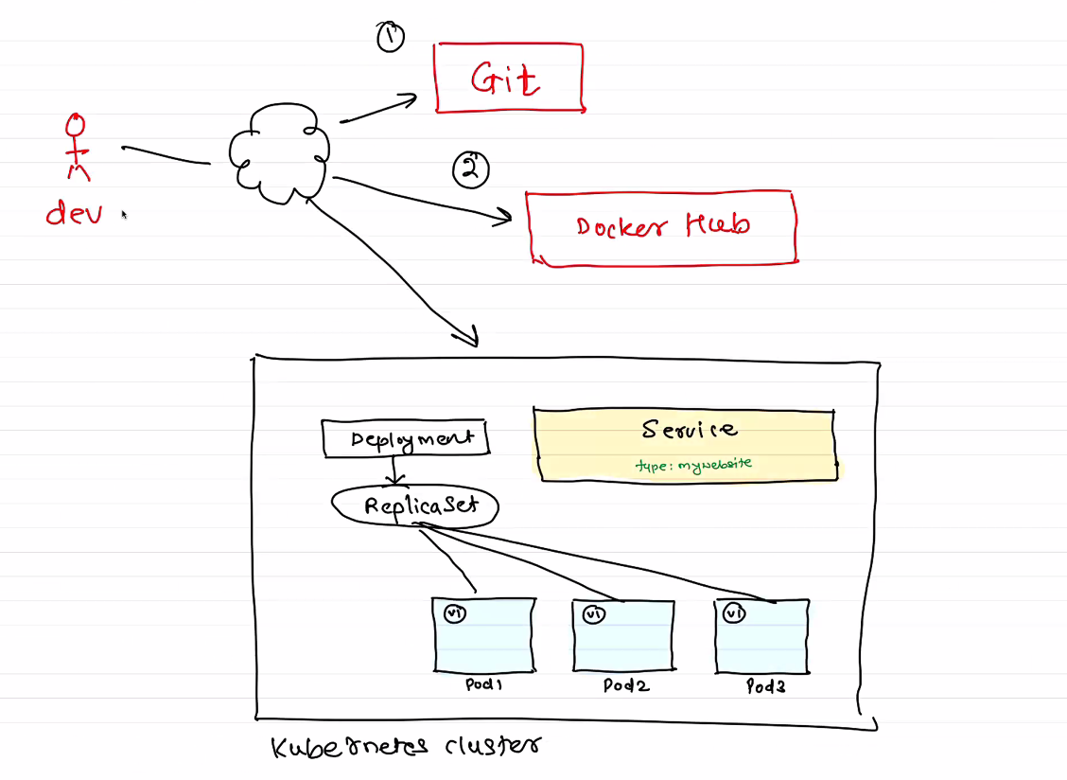

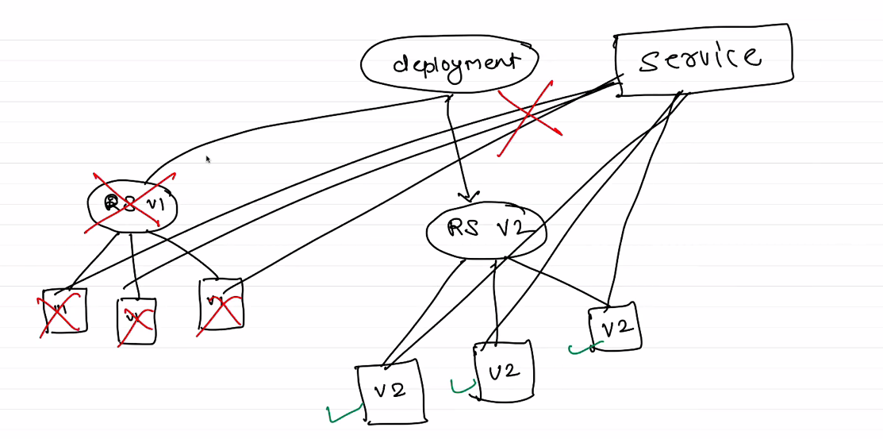

Deployment Rollouts.

Modifying the deployment.

Build a new version of image

Push that image in the docker hub

k rollout history deploy mywebsite-deployment

K edit deployment

Ways to update ht edeployment

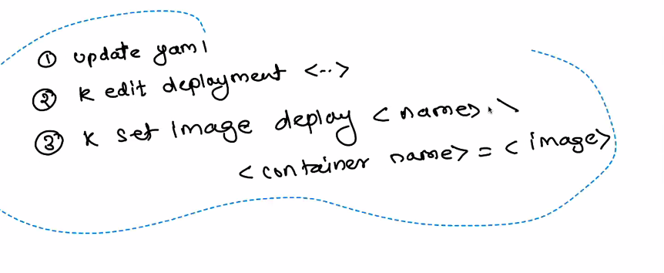

K set image deploy <name>

Change the versions:

K rollout undo deploy mywebsite-deployment --to-revision=1 (or2,3,4)

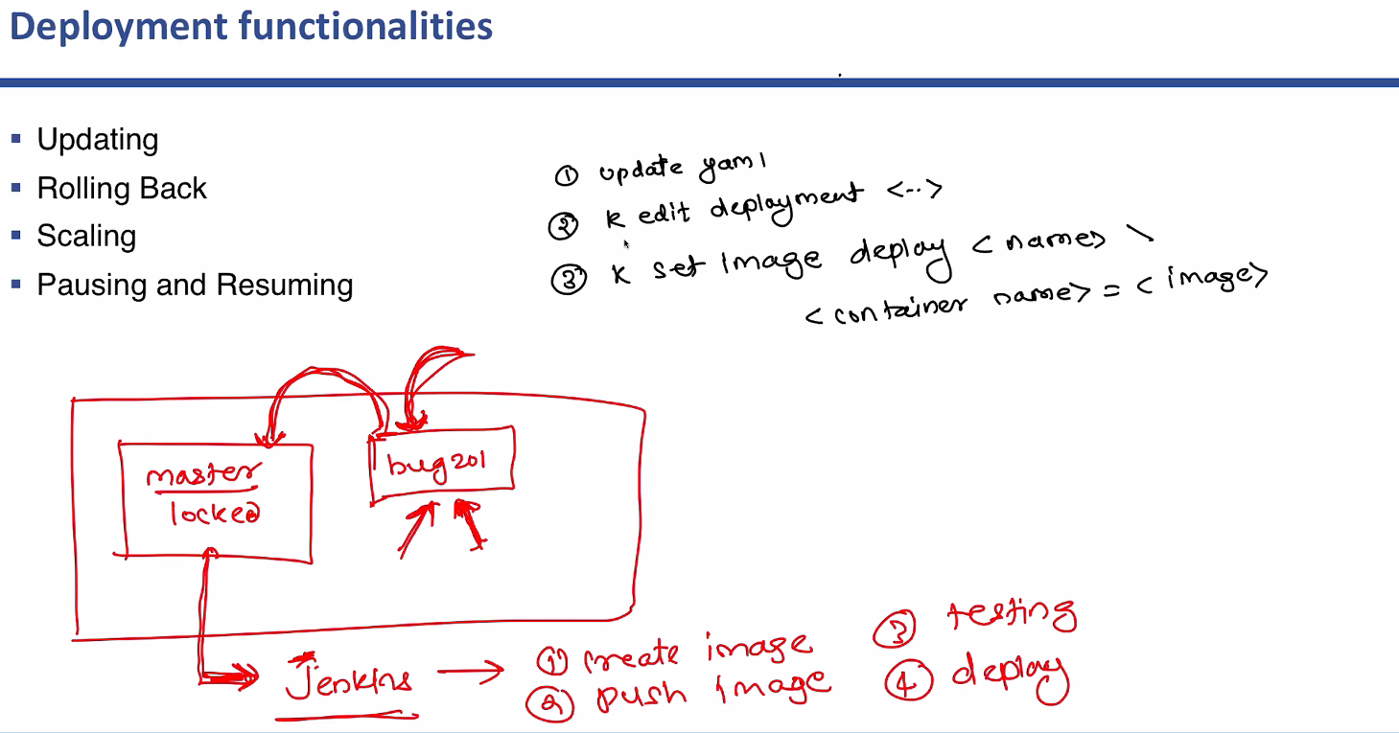

Rolling back and update is very important.